Winter Reality Show Madness

# The Shows

The Bachelor - Mondays 8PM, ABC

**Overview:** 30 women vie for the heart of 28-year-old Delta Airlines pilot Peter Weber (a/k/a Pilot Pete). Peter bounces back from a devastating breakup with former Bachelorette and Dancing with the Stars champion Hannah Brown for his chance at love.

**How it works:** Each week, Peter will go on several dates to get to know the women. The end of the week culminates in a Rose Ceremony. One by one, Peter calls out the names of women and asks them the fateful question, “Will you accept this rose?” Those who do not receive a rose are eliminated.

**Status:** Premiered 1/6; the 30 women are down to 19.



Project Runway – Thursdays 9PM, Bravo

**Overview:** Make it work! No Heidi Klum or Tim Gunn to keep this show afloat, but sixteen designers will compete to become "the next great American designer."

**How it works:** Each week, the designers must design a runway-ready look in response to a unique challenge limited by time, materials, and theme. A panel of judges evaluates the designs and the designer with the weakest look that week is eliminated.

**Status:** Premiered 12/5; 16 designers began and 9 remain.



Kids Baking Championship – Mondays 9PM, Food Network

**Overview:** A dozen 10- to 13-year-olds that far exceed my own baking skills—may the best kiddo win. Surely the most wholesome bit of television in this lineup.

**How it works:** The children compete each week to make the best dish, and are judged on presentation, taste, and creativity. One unfortunate little baker gets eliminated each week.

**Status:** Premiered 1/6; 12 youth bakers are down to 10.

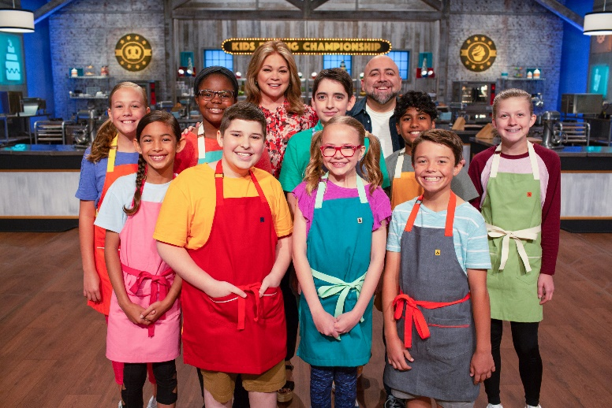

Survivor – Wednesdays 8PM, CBS

**Overview:** 20 winners of previous Survivor seasons are placed in an isolated location, where they must provide food, fire, and shelter for themselves. The contestants compete in challenges for rewards and immunity from elimination.

**How it works:** Each week, one contestant is voted “off the island” by their fellow contestants, until only one remains and is given the title of "Sole Survivor".

**Status:** Premieres 2/12.



Top Chef All Stars – Wednesdays 9PM, Bravo

**Overview:** Hands up, utensils down. Contestants from previous seasons of Top Chef compete against each other to crown the true Top Chef.

**How it works:** Each episode starts with a Quickfire challenge, the winner of which receives some sort of advantage or immunity. Then, the Elimination Challenge begins and the chefs race the clock to prepare a dish to satisfy the requirements of the challenge. A panel of judges (comprised mostly of celebrity chefs) evaluates each dish and selects a winning and losing dish. The losing chef is eliminated.

**Status:** Premieres 3/19.



|  |  |  |  |  |
| --- | --- | --- | --- | --- |
| **The Bachelor** | | | | |
| Contestants Remaining | Est. Weeks Remaining | Points per week | Bonus Structure | Contestant List |
| 19 | 10-12 | 1 | 1st: 5  2nd: 3  3rd: 2  4th: 1 | [Link](https://en.wikipedia.org/wiki/The_Bachelor_(season_24)#Casting_and_contestants) |

|  |  |  |  |  |
| --- | --- | --- | --- | --- |
| **Project Runway** | | | | |
| Contestants Remaining | Est. Weeks Remaining | Points per week | Bonus Structure | Contestant List |
| 9 | 7 | 1 | 1st: 3  2nd: 1 | [Link](https://en.wikipedia.org/wiki/Project_Runway_(season_18)#Designer_Progress) |

|  |  |  |  |  |
| --- | --- | --- | --- | --- |
| **Kids Baking Championship** | | | | |
| Contestants Remaining | Est. Weeks Remaining | Points per week | Bonus Structure | Contestant List |
| 10 | 9 | 1 | 1st: 3  2nd: 1 | [Link](https://en.wikipedia.org/wiki/Kids_Baking_Championship#Elimination_Table_8) |

|  |  |  |  |  |
| --- | --- | --- | --- | --- |
| **Survivor: Winners at War** | | | | |
| Contestants Remaining | Est. Weeks Remaining | Points per week | Bonus Structure | Contestant List |
| 20 | 13 | 1 | 1st: 5  2nd: 3  3rd: 2  4th: 1 | [Link](https://en.wikipedia.org/wiki/Survivor:_Winners_at_War#Contestants) |

|  |  |  |  |  |
| --- | --- | --- | --- | --- |
| **Top Chef: All Stars** | | | | |
| Contestants Remaining | Est. Weeks Remaining | Points per week | Bonus Structure | Contestant List |
| 15 | 14 | 1 | 1st: 3  2nd: 2  3rd: 1 | [Link](https://en.wikipedia.org/wiki/Top_Chef_(season_17)) |

_______________________________________________________ END DRAFT 1 ________________________________________________________________________________________________________________________________-

The Masked Singer – Wednesdays 8PM, FOX

**Overview:** A group of celebrities compete on the show anonymously in costumes over a series of episodes. The competition aspect is about the singing, but the *fun* of it is trying to guess which random celebrity is “The Flamingo” or “The Tree”. Last season “The Fox” won—who ended up being Wayne Brady.

**How it works:** Each episode, a portion of the competitors are paired off into face-off competitions, in which each perform a song of his or her choice in their real voice. From each face-off, the panelists and live audience vote; the winner is safe for the week, while the loser is put up for elimination. At the end of the episode, the losers of the face-offs are then subjected to the earlier votes of the panelists to determine who will not continue; the eliminated singer then takes off their mask to reveal their identity.

**Status:** Premieres after the Superbowl.



Survivor – Wednesdays 8PM, CBS

Sdasdfha

American Idol – Sundays and Mondays 8PM, ABC

Asdfkla



The Voice – Mondays and Tuesdays 8pm, NBC

Status: Premieres 2/24